Oakwood School & Assessment Centre

Annual Report of the Board of Governors

2020-2021

Dear Parent/Carer
I am very pleased to have this opportunity to present to you the Annual Governors' Report for the school year 2020-21. A year that was unprecedented not only in educational terms but across all of society. The devastating impact of the Covid 19 pandemic was felt across our school on a number of different levels. However, thanks to you our parent body, the dedication of our staff and the work of the NHS our children were in the main protected both physically and emotionally.

This Annual Report, a legislative requirement prepared by the school Principal, is another method by which the Board of Governors and the Principal endeavour to keep everyone fully informed and involved in all the work and activities, of the school.
The Board of Governors of Oakwood School is made up of enthusiastic and committed people who work in close partnership with the staff of the school, to ensure that each child reaches his/her fullest potential. Those on the Board of Governors come from various walks of life and each is dedicated to enhancing the educational experience and outcomes for all those in our care.

In preparing this Annual Report of the Board of Governors we have again been conscious of the tremendous breadth of educational experiences that the Principal and staff provide for your children. We are also very aware of the responsibility placed upon teachers and support staff, to keep them safe and secure during this current crisis, to provide supportive pastoral care and to provide pathways that build life skills and develop as much independence as is possible for each individual pupil.

On behalf of all the Board of Governors I would like to take this opportunity to thank all our parents/carers for their tireless support and understanding in the work of the school throughout this, and every school year. Such help is so very much appreciated. I trust you will find the report interesting reading. If there is any aspect of the report that you are unclear on, please do not hesitate to contact either myself or the Principal.

Yours sincerely
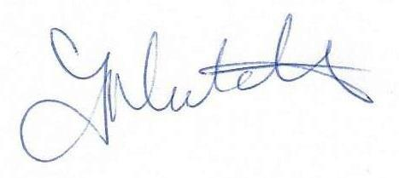Chair of Governors

The Board of Governors
The composition of the Board of Governors of Oakwood School for the school year 2020-21 was as follows:
Parents' Representatives: Frances Hutchins(chair)
Joanne Skelly
EARepresentatives: Pip Jaffa (appointed Oct 2020)
Louise Kane (appointed Oct 2020)
DENI Representatives: Ann McCann (appointed April 2021)
Catherine McGuinness (appointed April 2021)
Teachers' Representative: Tom Ferran
Secretary and Principal: Tish McCann

The Governors of the school are ultimately responsible for the overall management of the school. Our duties include:

- The oversight of all aspects of the school curriculum.
- The control of all finances.
- The provision of information to parents/guardians.
- The appointment of all staff - teaching and non-teaching staff.
- Fostering links with the local community.
- The maintenance of premises (shared with EA).
- Health and Safety
- Child Protection

Governors’ Meetings 2020-21
During the school year 2020-21the Governors met initially via zoom and then face to face for shortlisting and interviewing of classroom assistant and teacher posts. The Chair and principal maintained regular telephone contact throughout the year, to discuss responses to the evolving Covid crises.

Sub Committee meetings (recruitment):
Teachers post :- Tom Ferran, Louise Kane, Frances Hutchins, Catherine McGuinness
Shortlisting Interviews
27th May 2021 14th June 2021
Classroom Assistants :- Tish McCann, Pip Jaffa, Ann McCann, Frances Hutchins
Shortlisting Interviews
27th May 2021 16th June 2021

The Education Reform Order stipulates that all Controlled schools must be managed by a Board of Governors and rules for establishing such are clearly defined. Parents are entitled to elect two Governors and teaching staff are entitled to elect one Teacher Governor. In accordance with these procedures our present Board of Governors was constituted to serve for a period of four years from 2018-2022.
All members of the Board of Governors serve in a voluntary and 'unpaid' capacity.
The Board of Governors is pleased to note that the school provides the very highest standards for all of our children, as it provides excellent teaching and learning experiences. We work with many allied professionals and outside agencies to provide the care pupils require to access their learning and to develop skills and aptitudes they need.
Both the staff and Governors of Oakwood school appreciate the support of parents as we implement school policies in a consistent, fair and caring manner across the school. Close co-operation between home and school continues to be critically important for the success and well-being of our pupils.
In addition, the school is grateful for the services of a number of Health Service staff – Nurse, Speech & Language Therapists; Occupational Therapists and Physiotherapists. Such colleagues, whilst not employed by the school, do supplement the educational provision we provide.

Staffing Compliment
The staffing compliment throughout 2020-2021 was made up of Principal, Vice Principal (shielding and working from home) Acting Vice Principal, 23 teachers, 20 Classroom Assistants, 37 General Assistants, 2 school secretaries, and 6 ancillary support staff.

Principal
Tish McCann
Vice Principal
Lynn Laverty
Acting Vice-Principal
Tom Ferran
Senior Teacher
Deirdre Currie
Teaching Staff
Rhona Grant
Caraline Ward
Debby Kerr (shielding)
Nathan Armstrong
Aisling Crossan
Rosemary Starrett (shielding)
Addele Lynas
Marian Doan
Michelle Walsh
Michael Carson
Petrina McCann
Rebecca Kenny
Danielle Conlon
Temporary Teachers
Rebekah Johnston
Ciara McDermott
Ben McMullan
Colum Harris
P/T Temporary Teachers
Niall Donnelly
Ronan Wright
Classroom Assistants
Sharon Beatty
Gillian Gibb (shielding)
Karen Gillespie
Deborah McCabe
Louise Rice
Louise McCarten
Margaret Smyth
Lindsay Stevenson
LauraMcPoland (shielding)

Temporary Classroom Assistants
Orlagh Wisdom
Claire McTasney
Denise Crossin
Jane Feeny
Tammy Millar
Andrea Grattan
Donna Sweeney
Rebecca Brown
Karen Murray
Ryan McMullan
Helen Scott
Seanna McAreavey
Julie Carlise

General Assistants
Bronagh Bamber
Edele Gallagher
Ruth Gordon
April Murray

Temporary General Assistants
Lauren Armstrong
Ryan Bloomer
Erica Bradshaw
Denise Conlon
Jennifer Devlin
Stacey Duggan
Laura Fitzsimons
Stephanie Gauld
Courtney Grimshaw
Melissa Hill Caitlin Kelly
Christopher Magee
Katie Magee
Patrick Magennis
Rachel Magennis
Rebecca Magennis
Kirsten Maguire
Laura Mathews
Charlene Meehan
Moya Mervyn
Victoria Milligan
Carla Miskelly
Roisin McCabe
Angela McGinn
Ashley McMullan
Kerri Ann McNarry
Maria ONeill
Kaitlyn Oprey
Joanne Reid
Zoe Rooney
Nicole Ryan
Kirsty Shaw
Lindsay Ward
Natasha Ward
Janine Whiteway
School Secretaries
Mandy Draper
Marbeth McClure (shielding)
Ancillary Staff
David Rowan
Linda Rowan
Patrick Magennis
Stephanie Gauld
Joanne Reid
Michelle Ross

Review of the Past Year

The 2020-21 school year was like no other. The year began earlier than usual (17th August) when the Education Minister changed the dates of the school holidays. The Senior Leadership Team had worked tirelessly during the summer break to ensure that the school population, pupils and staff would be able to return in as safe a manner as possible. Prior to reopening staff were issued with the new Covid protocols and procedures and were trained in the donning and doffing of PPE. Teaching and classroom assistant staff received training on the ‘recovery curriculum’ and the school was ‘made safe’ in terms of resources and classroom spaces. Children initially returned to the classroom on a part time, phased basis. Classes remained separate at all times in ‘class bubbles’.
Assembly became a virtual experience as we connected via zoom, whilst this was very much a ‘second best’ it allowed staff and pupils to connect on some level.
An online and blended learning policy was developed and shared with parents. This ensured that in the event of another lockdown or partial closure everyone was clear about the educational offer to our pupils. It also established policy for those children who were shielding. The teaching of those pupils being undertaken by the staff shielding and working from home.
In November the number of Covid cases escalated across the school and staffing levels became dangerously low we moved to a blended learning approach for all with review every 4 weeks. By February all classes were reopened for fulltime face to face teaching.
In April DE confirmed two new governors thus making the governors ability to quorum and so manage the school a more shared process.
Following the Core Staffing meeting the EA agreed to move any teacher and classroom assistants posts that had been maintained on a temporary basis to permanency and to approve advertisements for the remaining teacher and classroom assistants’ posts. They further agreed to investigate the same process for general assistants in the next academic year.
Following a meeting with EA and the other Belfast Special School principals’ information about the opening of a satellite site for Harberton was shared and we were informed of the likelihood of some of our transfer pupils moving to it. After visiting the site and discussion with the principal I was convinced of the ability of the school to cater for our pupils.
Harberton school kindly allowed their Team Teach Tutors to provide an essential training update for all teachers and classroom assistants and so ensured that our training remained valid.

The School Curriculum

At Oakwood we recognise the need for a ‘broad and balanced curriculum’ but recognise this means different things for different pupils. We take ideas and methodologies from documents produce by the Department for Education and elsewhere. Individualised learning plans are delivered through the recovery curriculum framework. The planning we use and content we deliver is set as relevant and appropriate to the developmental needs of that pupil, and so provides for meaningful learning. We provide a flexible, personalised, needs driven curriculum and so our teachers use their knowledge and professional expertise to adapt their plans and practise and so provide the content, they consider is best for their pupils.
At Oakwood we believe there is no single curriculum that suits all our pupils, no ‘set’ of subject areas and that the curriculum must be individualised to meet the needs of the individual pupil.
Over the course of this academic year we fully embraced the ‘Recovery Curriculum’ and adapted our IEPs accordingly. This led to a more needs focused approach to the curriculum and provided an appropriate education for all of our pupils.
We provided a personalised learning pathway for each and every pupil at Oakwood designed to prepare our pupils for the adulthood they will experience.

Child Protection/Designated Teachers and Governor
The health, safety and well-being of our children and staff is an important priority for us as governors. We would like to thank all of the staff for ensuring that the area of child protection and well-being, of both pupils and staff, is an ongoing priority across the school and all concerns in this area were referred to the appropriate authorities.

Pre School Provision/ Getting Ready to Learn
In the year 2020-21 we were successful in securing funding for a ‘Getting Ready to Learn’ project. This project provides information for parents of preschool children. We focused on two themes, education works (play and communication) and happy healthy kids (outdoor and physical play). Due to Covid restrictions parent training was delivered via short videos and parent information leaflets. Funding enabled us to purchase outdoor play equipment for children at home. This was very well received by the parents of all our nursery aged children.

School Leavers
This year our year 4 leavers moved to a number of different schools across the province. While we were unable to physically introduce our children to their new schools our staff and those of the receiving schools met (via zoom) and devised ways of providing a transition experience via video and photographs.

First Communion/ Confirmation

We had 5 pupils who were of the age to make their first Communion . Unfortunately, due to the Covid restrictions we were unable to join with our families. Despite this Rhona Grant did an excellent job in preparing the children and representing the school.

Summer Scheme
For the first time ever Oakwood School offered a Summer Scheme this was organised and led by Michael Carson. DE provided targeted funding for schools and a two-week summer scheme was hosted for our year 4 transition pupils. This was a highly successful venture and we hope to be able to bid for funding to repeat it in future years The Board of Governors acknowledge the excellent provisions made by the staff who organised the Summer Scheme.

School Meals
Thanks are also due to Fleming Fulton School kitchens who on a daily basis cook around 100 very tasty meals every day.

Parental Support & Working with families

We acknowledge that parents know their child better than anyone else and we encourage all of our parents to work in partnership with us so that together we can help each child develop to his/her full potential. The ‘child’ is the starting point for everything that goes on at Oakwood and parents are reminded that we have an ‘Open Door Policy’ unfortunately due the Covid restrictions in place we were unable to meet face to face with parents except by appointment last year. Despite the difficulties imposed by Covid we worked creatively and effectively with our families and developed our use of technology especially See Saw. The staff of Oakwood School recognised the need to help support some of our families on a practical level and began a food bank. Deirdre Currie coordinates this and ensures weekly food parcels for those families who need support in this way. My thanks to all our staff for their generosity.

In Conclusion
The Governors would sincerely thank everyone involved in the ever expanding and enriching learning experiences which have been typical of Oakwood School for many years.
To all of the staff, both teaching, non-teaching and ancillary, to those individuals and groups who have supported the school over the past year, we would say a sincere thank you.

School Finance
All school finances, irrespective of source, are subject to the normal annual auditing and accounting procedures of the EABR.

During the 2020-21 school year, gifts to the school, both monetary and equipment items, were received from many individuals. All such gifts were acknowledged in writing.
Such gifts allow items and experiences to be bought for classes that otherwise could not be purchased. The Board of Governors are very appreciative of the generosity of people for their continued support for the school.

The Financial Report presented below refers to the money allocated to the school through the Board’s Article 60 funding. Responsibility for the management of this budget lies with the Principal and Board of Governors.

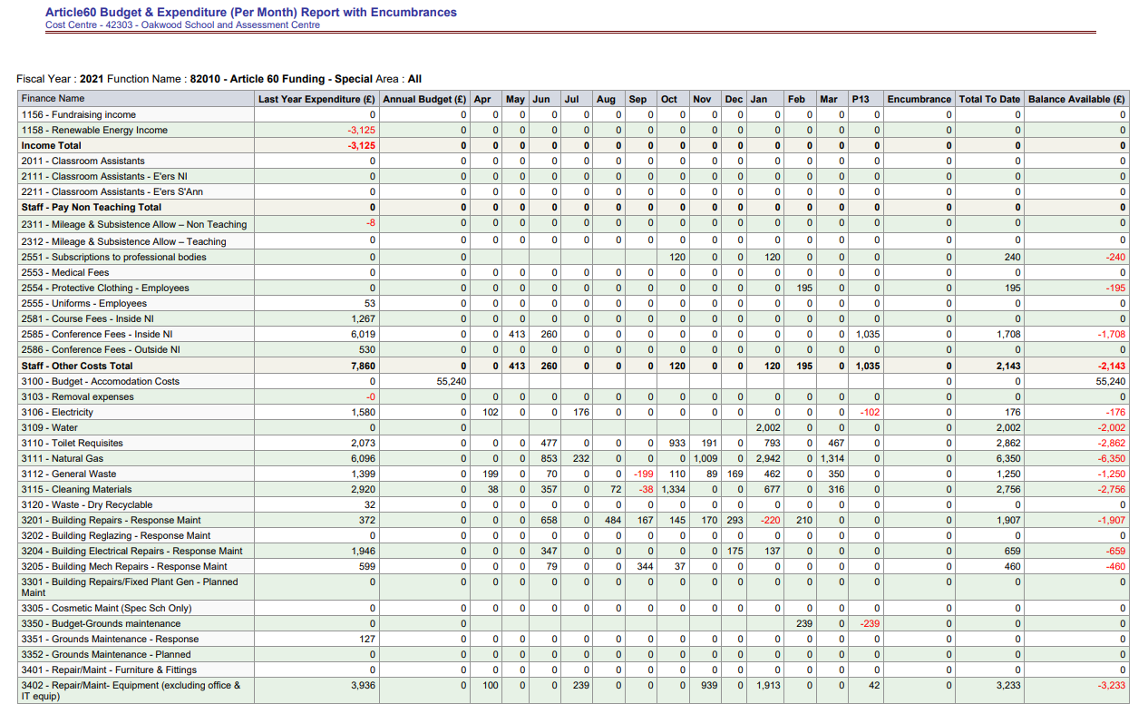
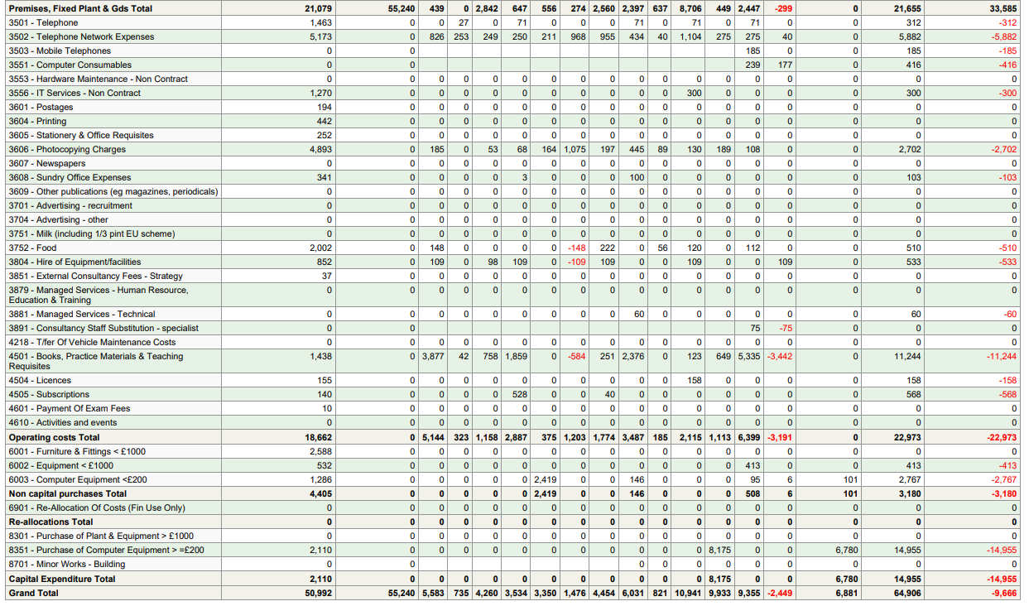

Oakwood School Fundraising Account Aug 2020 – Sept 2021

Starting Balance £770.52
Money In | Money Out
£500 Ernest Cook Trust Grant | £245 Storage Boxes
£313.70 Non Uniform Day | £264 Jeans for Genes donation
£84.55 Easy Fundraising | £18.75 Keys Cut
£481 Signature Works | £122.68 Sensory Equipment
£500 | £800 Santa and Christmas
£88.75 Easy Fundraising | £13.19 Bank Charge
£124.43 Easy Fundraising | £15.38 HDMI Cables
 | £15.34 Bank Charges
 | £134.25 School Supplies
 | £9.84 Bank Charges
 | £500 Summer Scheme
 | £13.86 Summer Scheme
 | £28.10 Summer Scheme
Total In | Total Out
£2092.43 | £2180.39

New Balance £682.56

