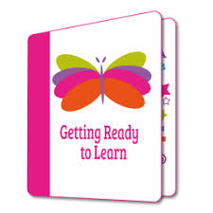
Getting Ready to Learn Programme
2020-2021

At Oakwood we are engaged with an Early Years Programme called Getting Ready to Learn. This is funded by the Education Authority and provides information for parents of preschool children. In previous years we have held workshops here at school for all of our Nursery parents. Topics covered have included The Nursery Day; The Nursery Curriculum; Communication; Play and Establishing Routines.
This year our programme will be delivered by short video presentations, available to our Nursery parents. Parent information packs will also be sent home.
We have 2 themes this year, focusing on ‘Education Works’ (Play and Communication) and ‘Happy Healthy Kids’ (Outdoor and Physical Play).
This week the children in our Nursery classes each received a bag of toys to encourage outdoor physical play at home.

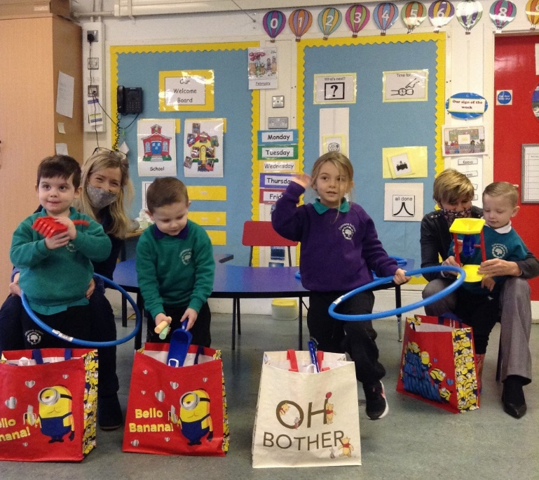

Bags of fun for outdoor play!

